

**Top view of four ACS boards in flight configuration**

**OreSat bus**

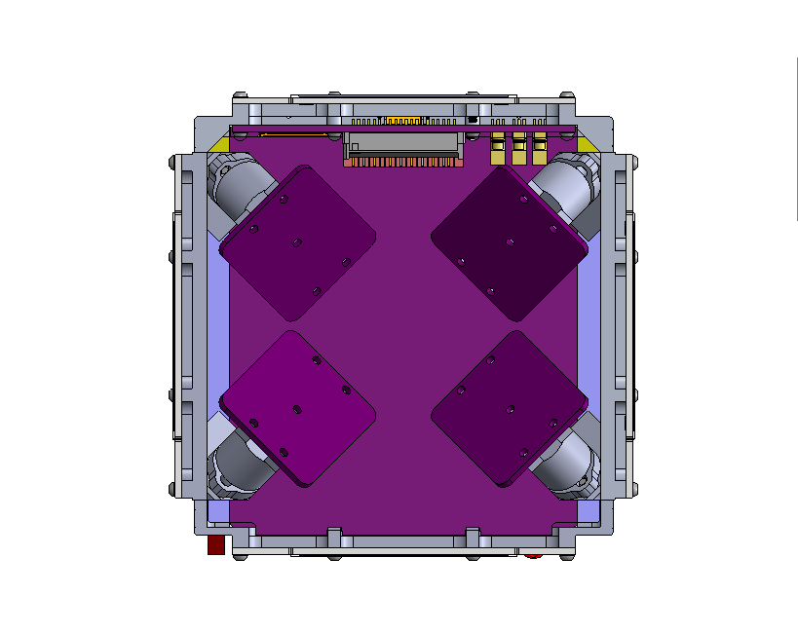

Only three motors will be needed for full 3-axis control. Four motors allows redundancy in case one ACS board or motor fails while in orbit.

**Side view of two ACS boards in flight configuration**

**OreSat bus**

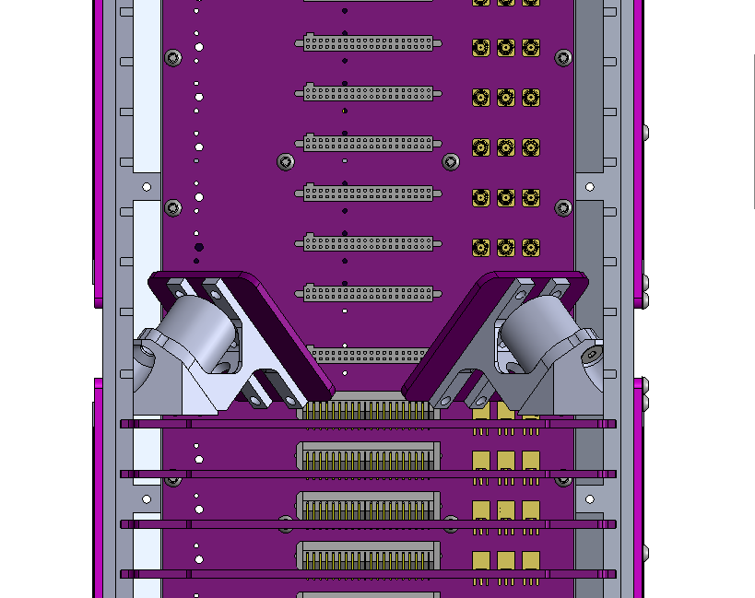

The motors will be situated in a ring half-way up the satellite. Like every other component of the satellite, the ACS assembly will be modular. The “card” it is on will be able to slide in and out of the frame for easy assembly. The ACS assembly will take four “cards” worth of space.

**Reaction Wheel Controller (one per ACS board)**

Phase-vector control uses sinusoidal waveforms.

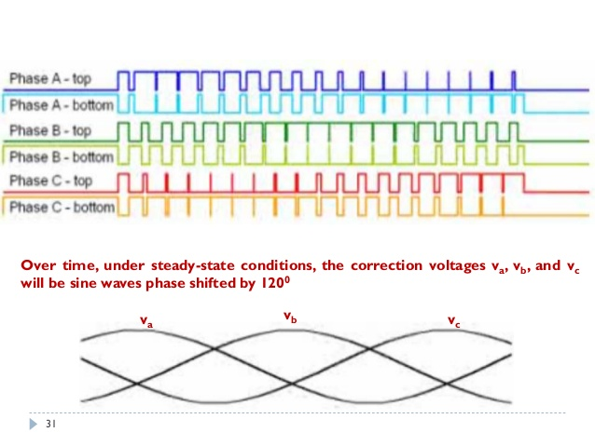

We generate the three sinusoidal waves using six Pulse-Width Modulation (PWM) signals, one for each phase, and one for each phase complimented.



The six PWM signals are fed into a triple-half H-bridge, which sends current into the Brushless-DC (BLCD) Motor.

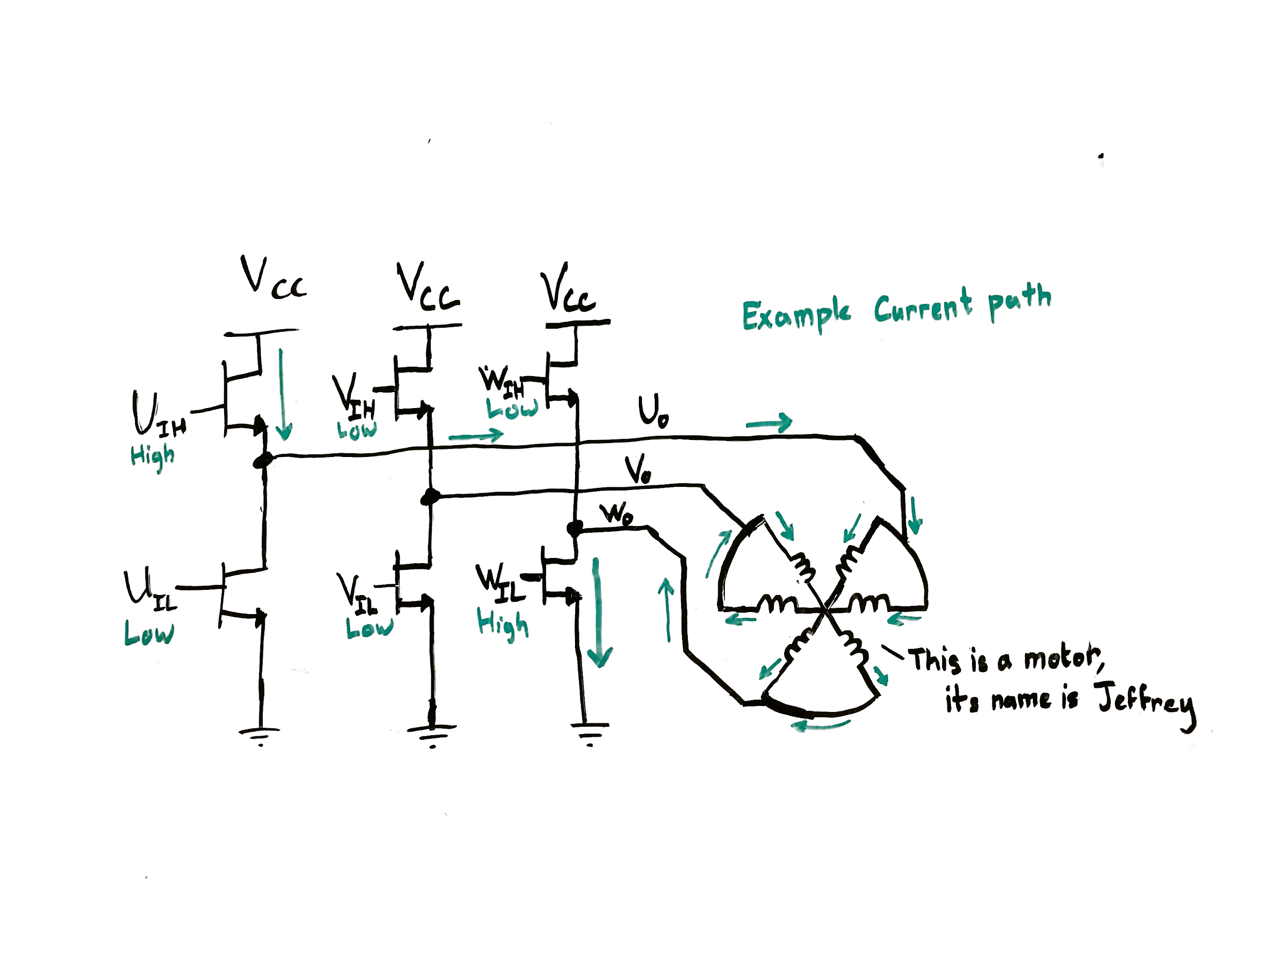

**Magnetorquer Controller (one per ACS board)**

Magnetorquers are inductors, and can be controlled with an H-bridge.

